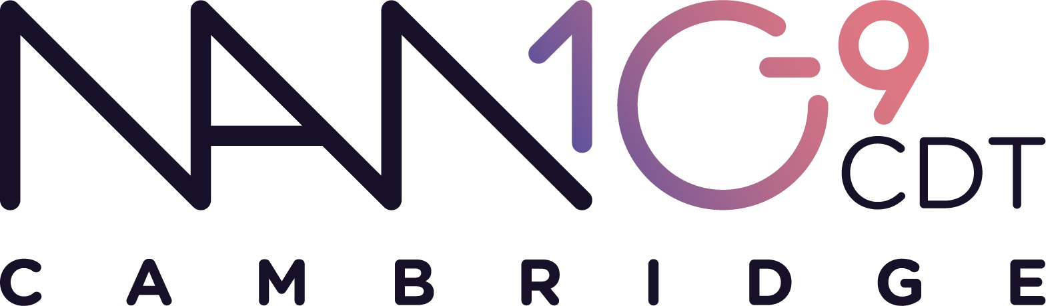
www.nanodtc.cam.ac.uk
EPSRC CDT in Nanoscience and Nanotechnology (NanoDTC)
Mini Project Proposal Form – submission deadline 14th Oct 2021
Please upload this form on this link

Principal Investigator (PI)  Name:  Department:  Email:  Website: | Daily supervisor (PDRA or senior PhD student)  Name:  Department:  Email:  PDRA or PhD student?  If PhD student, please indicate if completed 1st year exam
2nd Principal investigator (PI) in another department ⁽¹⁾  Name:  Department:  Email:  Website: | 2nd Daily supervisor in another department (PDRA or senior PhD student)  Name:  Department:  Email:  PDRA or PhD student?  If PhD student, please indicate if completed 1st year exam
Project Dates:
Mini project 1: 29 Nov ’21 – 4 Feb ’22 (2 week break over Christmas)
Mini project 2: 14 Feb ’22 – 8 Apr ’22
If the project can only be offered for either Mini 1 or Mini 2, please indicate here:
Title:

Project Outline (max 500 words, inc a diagram):

Useful Information

- All NanoDTC projects need a second PI from a different department from the main PI (or a very different discipline). This is for encouraging high impact work that can emerge from cross-disciplinary collaboration. If you need assistance in finding a suitable collaborator for your project, please email kj259@cam.ac.uk

- Mini-projects are 8 weeks long (students have other lectures and assessment ongoing, so this is equivalent to around 5-6 weeks full time equivalent). Therefore the projects require well defined goals and adequate supervision. Please bear this in mind when indicating which project dates are suitable.

- Each Mini project has one or two daily supervisors who offer day-to-day guidance to the student. In most cases this is a postdoc, or a senior PhD student. PhD students should ideally be in their final year, or should have atleast completed their 1st year exam successfully in order to be eligible to be a daily supervisor. If this is not the case, PIs must write to team@nanodtc.cam.ac.uk with a suitable justification.

- Payment is available to daily supervisors @ 0.5 hours a day per student (20 hours in total for 8 weeks of the project). The allocated 20 hours of paid supervision time can be shared between the two daily supervisors as they agree between themselves. The default split for this payment is 17 hrs to the 1st daily supervisor and for 3 hrs to the 2nd daily supervisor unless we are informed otherwise.

- Midi and PhD proposals will be invited later in the year (deadline in February)

Please complete and upload this form on this link

